EASTBANK PRIMARY SCHOOL

SCHOOL HANDBOOK

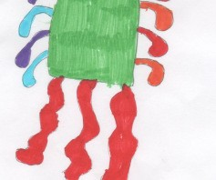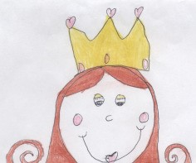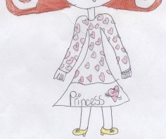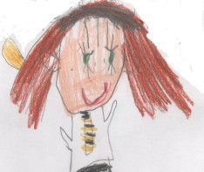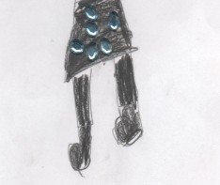

SESSION 2019-2020

EASTBANK PRIMARY SCHOOL

80 GARTOCHER ROAD

GLASGOW G32 OHA.

TEL: 0141-778-6659

FAX NO.0141-764-0908
Winners 2014
Winners 2014
E-MAIL: headteacher@eastbank-pri.glasgow.sch.uk
WEB SITE: www.eastbank-pri.glasgow.sch.uk

A very warm welcome to you and your child from the team at Eastbank Primary
School! We look forward to sharing the next seven years with you! We hope you will find Eastbank to be a warm and friendly place where every child can reach their full potential.

Teaching and Support Staff are highly dedicated and talented professionals who put our children first and greatly value their relationships with them. Our children need to feel happy and safe to achieve their potential.

I am delighted to share that we are the proud winners of a Scottish Education Award, Scottish School of Co-operation Award, 4 Eco Green Flags and a Language and Communication Friendly School Accreditation. Our Eastbank Primary School family are highly committed to excellence in attainment & achievement and nurturing the positive emotional, mental, social and physical health and wellbeing of all pupils.

In partnership with you we will encourage your child to have a positive attitude to learning, to be confident in his/her ability, to contribute to the life of the school and to show good citizenship within the school, local community and the wider world.

A variety of activities are arranged throughout the year giving parents an opportunity to meet with staff. We look forward to meeting you on as many of these occasions as you can manage. Nothing benefits a child more than a close working relationship between school and home.

At all times we operate an open door policy and if you have any worries or concerns regarding your child’s progress or welfare please contact us at the school by telephone or pop in and we will be happy to help.

I hope that this handbook gives you a glimpse of life at Eastbank Primary School. I am so incredibly proud of our school and know that you and your child will be too!

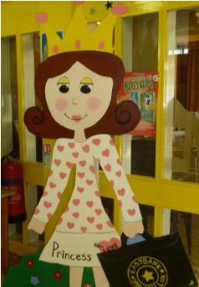
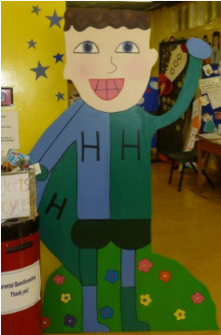
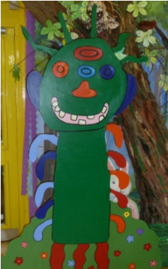
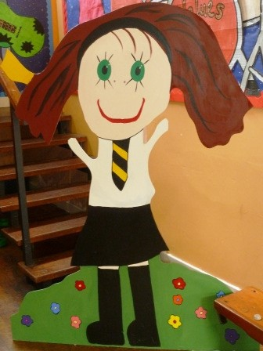
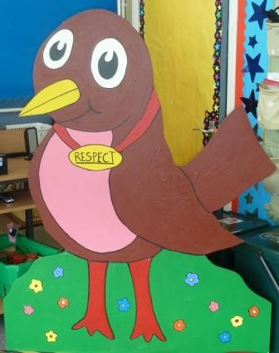

Gayle Minnis
Head Teacher

CONTENTS PAGE NO.

Welcome 1

Contents 2

Vision and Aims 3

Value Mission Statement / Value VIP Scheme 4

School Information 5 - 6

Staff Names 7

A Curriculum for Excellence 8 - 9

Curricular Areas 10 - 13

Assessment 13 - 14

Support for Pupils 15 -16

Home School Links Partnership with Parents 16 - 18

Equal Opportunities and Social Inclusion 18

Attendance at School 18 - 19

Promoting Positive Behaviour / School Councils 20 - 22

Anti Bullying / Medical and Health Care / Clothing and Footwear Grants 22 - 23

School Uniform / PE 23

School Meals - “Hungry for Success” and Transport 24

Child Protection and Child Welfare and Safety 25

Transfer from Primary School to Secondary School 25 - 26

Parent Forum/Parent Council 26

Data Protection Act 26

Information in Emergencies 26

Addresses and Contacts 27

School Holidays 28

Comments and Complaints 29

EASTBANK PRIMARY SCHOOL
Eastbank Family
Vision and Aim
Visions
Aims
Lead
Aiming to get it right
Us (to become)
Feeling Positive
Eastbank
Stars
Being
Feeling - positive as part of the Eastbank family
Aiming - to get it right
Being - respectful, responsible, fair, honest, polite

Together

Eastbank

Achieves

More

Eastbank Primary School
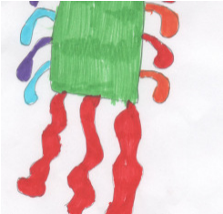

Values Mission Statement

“Give values the high 5”

Our values have been identified, developed and agreed in consultation with all pupils, staff, parents/guardians and members of our wider community.

Eastbank Primary Values

FAIRNESS is showing an awareness of all points of view.

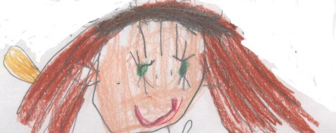
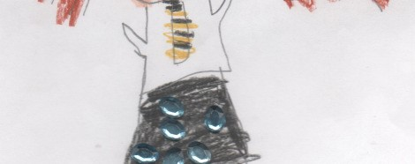
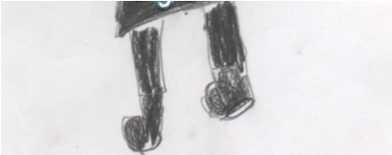
HONESTY is always telling the truth.

POLITENESS is using good manners to live together in harmony.

RESPECT is treating everyone and everything with consideration and care.

RESPONSIBILITY is making good choices for yourself and others.

All stakeholders are committed to living and sharing our values.

As a pupil, I will let my choices be guided by our shared school values.

As a school, we will promote and celebrate the values of fairness, honesty, politeness, respect and responsibility.

As a parent/guardian, I will encourage and support my child’s commitment to our shared values.

As friends of Eastbank, we will respect and promote the shared school Values of Eastbank Primary.

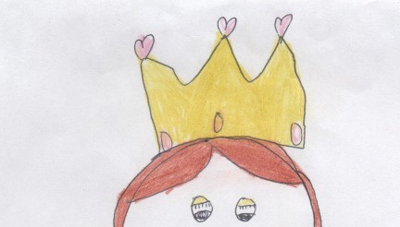
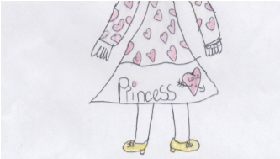
Our ‘Values Characters’ help us to live our values:-

FIONA FAIRNESS
HARRY HONESTY
PETER POLITENESS
ROBIN RESPECT
REBECCA RESPONSIBILITY

School Information

PRESENT ROLL: 270
PLANNING CAPACITY: 429
WORKING CAPACITY: 402

Organisation of Classes

The following guidelines set by Scottish Government apply.

P1 maximum 25
P2 & 3 maximum 30
P4-P7 maximum 33
Composite classes maximum 25

Parents/Carers should note that the working capacity of the school may vary depending upon the number of children at each stage and the way in which the classes are organised.

There are eleven classes ranging from Primary 1 to Primary 7. The school is co-educational and non-denominational.

Introduction to the School

EASTBANK PRIMARY SCHOOL is situated at the corner of Shettleston Road and Gartocher Road. It was opened in 1968. Our school comprises of ten Teaching Areas, Administration Offices, a Gymnasium, a Dining/Assembly Hall, STEM Central, Library, Art Room, Music and Drama Room, a STAR Hotel and a vibrant Garden Area.
We have our own kitchen which provides meals cooked and prepared freshly each day.

The accommodation in the school is used outwith school hours for after school clubs run by staff and visiting specialists including Dance, Rugby, Funcise, Spanish, Drama and Hockey clubs.

EASTBANK PRIMARY SCHOOL is one of 5 associated Primary Schools, 6 Pre-5 units and 1 secondary school (Eastbank Academy) which combine to form Eastbank New Learning Community.

We have an active Parent Council and Fundraising Committee and our pupils are well represented by our Pupil Council and Eco Committee.

Our School Day-
School day begins 08.50 a.m.
Morning Interval 11.00 a.m. to 11.15 a.m.
Lunch Interval 12.15 p.m. to 1.00 p.m.
Afternoon session begins 1.00 p.m.
End of school day 3.00 p.m.

Breakfast Club
We have a breakfast club in our cafeteria which provides breakfast to all children between the times of 8.00-8.45 a.m. This service is free to children who receive free school meals and there is a charge of £2.00 for all other pupils.

After School Care Service
The school liaises with a number of local after school care facilities. Please contact the school for more information.

ENROLMENT
Parents/Carers wishing to enrol their child may call at the school or telephone at any point.

PRIMARY 1 ENROLMENT
Children who are five years of age by the last day of February of the following year are normally registered using the online process during November and January of the year in which they start school.

Advertisements are placed in local papers by the Authority advising parents when online forms are available. Also we issue information for display in local nurseries and playgroups. Those parents considering a place at Eastbank are most welcome to arrange a visit and meeting with the Senior Leadership Team. We can give you a guided tour and answer any questions you may have.

Parents are reminded to bring their child’s Birth Certificate and two proofs of address e.g. utility bills, driving licence in your name when enrolling their child online.

Families living outwith the catchment area are welcome to make a placing request to attend Eastbank Primary School but must enrol their child at their local school as a first step. Further information is available using the following www.glasgow.gov.uk/index.aspx?articleid=8629

Primary 1 Intake
Following Primary 1 Registration Parent Induction Open Afternoons will provide parents/carers with more detailed information. In May/June our new Primary 1 pupils will be given the opportunity to visit their future Primary 1 classroom to fully prepare them for starting school.

Whole School ‘Soft Start’

Following the success of our P1 Soft Start we have introduced a ‘soft start’ for all our children. School will continue to officially start at 9.00am but our Primary 1 & 2 children and any accompanying adult are invited to make their way in to the Primary 1 cloakroom/classroom between 8.50am – 9.00am. This allows for an informal/friendly ‘passover’ between parent and teacher and give our children a chance to unpack, settle, play and chat until 9.10am when class teaching time will begin. All other children go to their classroom on their own to begin to settle for the day ahead.
For any children attending breakfast club or being dropped off earlier, our support staff and P1 teachers support our children to enter and enjoy.

SCHOOL STAFF

TEACHING STAFF.
Head Teacher Mrs Minnis
Depute Head Miss McBurnie
Principal Teacher Miss Wilson
Principal Teacher Miss McCabe

Primary 1A |  | Miss Steele
Primary 1B |  | Miss Walbaum
Primary 2 |  | Mrs Lawson
Primary 3/2 |  | Mrs Angley
Primary 3 |  | Mrs Milligan
Primary 4A |  | Mrs Campbell
Primary 4B |  | Miss Morgan
Primary 5 |  | Miss Crichton
Primary 6/5 |  | Mrs Clark
Primary 7/6 |  | Miss McLachlan
Primary 7 |  | Mrs Pentland / Miss Hensman
CLOL |  | Miss Wilson / Miss McCabe

SUPPORT STAFF
Clerical Assistants
Mrs Kelly
Mrs Henderson

Pupil Support Assistants

Miss Baird | Mrs Carr
Mrs Kelly | Miss McGrory
Mrs Tobin | Miss MacIntyre CDO
Miss Armstrong

Janitor
Mr Jim McNeil

Crossing Patrol
Miss Linda Hamilton

Catering Manager
Mrs A. Lafferty

A CURRICULUM FOR EXCELLENCE

Curriculum for Excellence 3-18

Curriculum for Excellence has been introduced to raise standards of learning and teaching for all 3 to 18 year olds. It aims to help prepare children and young people with the knowledge and skills they need in a fast changing world. As part of Curriculum for Excellence all children from pre-school to the end of S3 will receive a rounded education known as a Broad General Education (BGE). Curriculum for Excellence is all about bringing real life into the classroom and taking lessons beyond it.

Through the experiences we provide at Eastbank Primary School we want our children to become Successful Learners, Confident Individuals, Responsible Citizens and Effective Contributors. We are committed to providing children with a broad general education and focus on eight curriculum areas.

Expressive Arts | Health & Wellbeing | Languages | Mathematics
Religious & Moral | Sciences | Social Studies | Technologies

Progress in learning is indicated through curriculum levels as detailed below.

Level | Stage
Early | The pre-school years and P1 or later
First | To the end of P4, but earlier or later for some
Second | To the end of P7, but earlier or later for some
Third & Fourth | S1-S3, but earlier for some

Expressive arts: The inspiration and power of the arts play a vital role in enabling our children and young people to enhance their creative talent and develop their artistic skills.

Health and Wellbeing: Learning in health and wellbeing ensures that children and young people develop the knowledge, understanding and skills which they need now and in the future to help them with their physical, emotional and social wellbeing.

Science: Science and its practical application in healthcare and industry is central to our economic future, for our health and wellbeing as individuals and as a society.

Social Studies: Through social studies, children and young people develop their understanding of the world by learning about other people and places both past and present, societies, their beliefs and values.

Religious and moral education: Religious and moral education includes learning about Christianity, Islam and other world religions, and supports the development of beliefs and values.

Languages: Knowing other languages and understanding other cultures is a 21st century skill set for students as they prepare to live and work in a global society.

Mathematics: Mathematics equips us with the skills we need to interpret and analyse information, simplify and solve problems, assess risk and make informed decisions.

Technologies: The range of subjects in technical education has changed significantly over the last two decades and now includes craft, design, engineering and graphics.

There will be opportunities throughout the year for parents and carers to learn more about aspects of the curriculum and to be consulted about significant changes if appropriate.

P1 – P3 Curriculum Design: Curriculum for Excellence encourages child-led creativity in the classroom. It promotes critical challenging and questioning. It really makes teachers think about how they teach, recognising that we learn in different ways and presenting lessons in ways that suit the learning styles of the children.

At Eastbank Primary we have adopted a more creative approach to teaching and learning in Primary 1 and now provide children with more opportunities to learn through play and first hand experiences. These experiences help children to develop confidence in themselves as learners and build the necessary skills required to access the curriculum. We are also focusing on improving the children’s vocabulary which also supports children with both their reading and writing.

There has been lots of research carried out in Scotland in the last few years, highlighting a gap in young children’s vocabulary and enjoyment of reading. While we have made good progress in helping children read well in recent years, we are working extremely hard to ensure that literacy skills are developed throughout all areas of the curriculum and the children are equipped with the skills that they require as they progress through primary.

Active learning within Curriculum for Excellence doesn’t mean that children are actively running around. It is learning that engages children and challenges their thinking.
Motivated children who are actively engaged with tasks that have a clear purpose will retain and learn more and will be more likely to transfer the knowledge and be able to apply it in different situations.
Right from the outset, young children will be partners in the learning process; actively participating in the planning, shaping and directing of their own learning.
Through play, children can
- Work in partnership with others
- Express themselves
- Build their independence
- Make sense of their experiences
- Manipulate materials
- Test out new knowledge
- Develop new skills
- Make choices and decisions
- Solve problems… and lots more

Religious Observance

Our school is fortunate to have a close link with the local church. The minister assists with the Christianity element of Religious and Moral Education and provides opportunities for religious observance. Parents have the right to withdraw their child from religious observance and should inform the school in writing.

Our Journey to Excellence

As a school we work hard to embrace the key philosophies of A Curriculum for Excellence by supporting our children to become:-

Successful Learners Responsible Citizens
Confident Individuals Effective Contributors

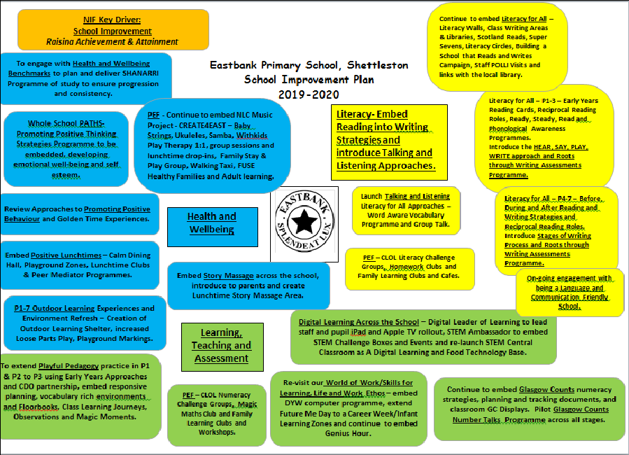
Our School Improvement Plan for 2019/2020 has the following priorities:-

LITERACY
Within Curriculum for Excellence, literacy is defined as a set of skills which allows an individual to engage fully in society and in learning, through the different forms of language, and the range of texts, which society values and finds useful.
At Eastbank Primary, literacy experiences and outcomes promote the development of skills in language, and recognise the importance of listening and talking.

Reading
At Eastbank we recognise the importance of reading as a skill required to access all other areas of the curriculum. To assist staff in constructing a programme for reading, suitable for the various abilities within our curriculum we use a wide range of resources and approaches:-

- We follow the citywide Literacy Programme Literacy for All which focuses on teaching pupils the tools and strategies required to decode, comprehend and engage with a range of texts.

- We teach phonics beyond our Infant Department all across the school (P1-P7) ‘Phonological Awareness’ is the ability to hear, recognise and differentiate between sounds and the spoken language. This is a vital reading skill that allows our pupils to ‘word attack’ and ‘decode’ unfamiliar words.

- We use PM Benchmark Reading Materials. PM Benchmark is a reading assessment module that ensures that books your child is reading are at just the right level for them – not too hard and not too easy! All the books are accurately levelled, and include a variety of fiction and non-fiction. We assess each pupil individually in order to identify the correct level for each pupil and have many class reading sessions throughout the week.

- We have a large number of novel studies to provide each class with many opportunities to explore and read a novel together.

- We use ‘Jolly Readers’ in P1-P4 which build on the skills and sounds introduced using the Jolly Phonic Programme.

- We encourage pupils at all stages to utilise class libraries to select books to enjoy at home.

- Our aim is to raise pupil attainment in reading and nurture the love of reading in all of our pupils!!

Talking and Listening
Children are provided with many opportunities to express themselves confidently in the spoken word, through e.g. drama, story telling, debating and developing listening skills.

Writing
All types of writing are taught, Personal, Imaginative, Functional and Writer’s Craft with teachers providing children with opportunities for “writing for a purpose.” We aim to develop in our children the ability to convey information accurately using suitable writing contexts, language and structures.
We also provide opportunities for pupils to express their feelings, reflect on ideas and experiences and use their imagination to gain pleasure in writing. We use BIG Writing VCOP strategies – Vocabularly, Connectives, Openers and Punctuation and the Roots through Writing Programme to assess learners progress.

Phonics/Spelling
In the Early Years spelling and phonics are taught as part of our Jolly Phonics and Jolly Grammar Programme involving a wide range of multi-sensory experiences and resources.
In the Upper Years we also follow a multi-sensory approach based on ‘Jolly Grammar’ – Look & Say, Trace & Cover, Write & Check!

NUMERACY
Numeracy and mathematics are important in our everyday life, allowing us to make sense of the world around us and to manage our lives. Using mathematics enables us to model real-life situations and make connections and informed predictions. It equips us with the skills we need to interpret and analyse information, simplify and solve problems, assess risk and make informed decisions.

Our Numeracy programme covers the following areas:- Number, Money and Measure, Information Handling, Shape, Position and Movement with a particular emphasis on Problem Solving and utilising skills and concepts in real life situations. We follow the citywide programme called Glasgow Counts focusing on strategies and learning through concrete, abstract and pictorial approaches.

Children are shown how to collect, organise, display and interpret information from graphs and databases and these skills can be used in other areas of the curriculum e.g. I.C.T and Social Studies. We use a range of mathematical resources to aid learning including Heinemann Mathematics, Tee Jay materials, I.C.T. programmes, calculators, measuring equipment, puzzles and games.

Our pupils are encouraged to be actively involved in their numeracy learning through practical experiences and discussion.

INTER-DISCIPLINARY LEARNING

In order to achieve the large number of Curriculum for Excellence Social Studies and Science Outcomes and Experiences pupils will learn through a range of topics and projects.
Each class enjoys a selection of topics each session and participates in as many educational visits e.g. museums, local parks as possible. We also organise and welcome input from visitors to our school. For example we have good partnerships with SOS, Generation Science, The Glasgow Science Centre, RSPCA etc.

EXPRESSIVE ARTS

Children are provided with a balanced Expressive Arts Programme which consists of Art, Drama and Music. P5-P7 pupils have the opportunity for violin, brass and woodwind tuition by our specialist teacher.

In recent years we have expanded our music curriculum via the CREATE4EAST Baby Strings Programme – A transformation and Innovative Project across 4 primary schools in the Eastbank Learning Community (Wellshot, Quarrybrae, Eastbank and Thorntree) using Pupil Equity Funding to raise attainment and close the poverty related equity gap.

Babystrings4east uses whole class delivery in P1-P4 by two specialist string instructors, working to
develop vocabulary, rhythm, pitch, rhyme, talking and listening and motor skills.

All children play a violin, viola or cello and enjoy performing at a range of concerts and events.

FRENCH

Children across the school are taught French, following the GCC programme introducing pupils to a range of key vocabulary using talking, listening, reading and writing approaches.

STEM (Science, Technology, Engineering, Maths)

We have a full programme of learning experiences to promote STEM in our school……
- Science Progression Planners
- Weekly STEM Challenges
- Pupil STEM Ambassadors
- Pupil Tech Team
- Digital Literacy Programme
- Range of Digital Learning Resources
- Engineering Club
- Links to World of Work / Real-Life STEM contexts

HEALTH AND WELL BEING

We are a recognised Health Promoting School and through our Health Programmes of Study and extensive Physical Education Programme we aim to foster a positive attitude to an active lifestyle, concern for physical well being and healthy eating. We use a range of programmes including PATHS (Promoting Alternative Thinking), Circle Time, Positive Play and Restorative Practices to conflict resolution.

Talented staff as well as a range of sport coaches ensures worthwhile experiences are provided for our pupils. In addition to P.E. sessions our pupils can enjoy additional physical activity sessions throughout the school year at breaktimes and after school.

Throughout the session children can participate in a huge variety of physical activities

Football
Swimming
Netball
Walking
Rugby
Basketball
Running
Gymnastics
Golf
Tennis
Dance
Hockey
Athletics
Cross Country Running

We also promote a healthy lifestyle through our Breakfast Club, nutritious school meals and healthy snack policy. We also provide chilled water for pupils to enjoy throughout the day.

ASSESSMENT
Eastbank Primary is an Assessment for Learning (A.I.F.L.) school – a place where everyone is learning together.

Aims:-
All learners will have the skills and opportunities to identify personal learning targets and to monitor their own progress against their goals.

Children, teachers and parents will engage in focused dialogue about children’s learning to celebrate achievement and identify next steps.

All learners will have a PLP and Assessment Portfolio.

All stakeholders will apply a range of “Assessment for Learning” skills to monitor and review progress.

Methodology:
Daily for example:
- Traffic light in jotters
- Help cards e.g ‘I can do it’ or ‘I’m not sure yet.’
- Thumbs up
- Post It board

Weekly Learning Logs / Floor-books
Learning logs are completed on a weekly basis, children record:
- What I have learned this week
- Magic moment of the week
- Target for the coming week
Continuous Formative and Summative Tracking:

Say, Write, Make and Do Pupil Profiles and Personal Learning Planning

Each pupil has an individual portfolio entitled a ‘Say, Write, Make and do Profile which pupils and teachers use to store a range of evidence from all curricular areas. Each pupil completes a Weekly Learning Log and has a Personal Learning Log which are used to support learners to identify personal targets and to monitor their own progress.

Tracking Breadth and Balance of the Curriculum

We use a whole school system of tracking breadth and balance of the experiences and outcomes over the course of each year as well as the whole level. Teachers log as each experience and outcome has been experienced, recording the context and methods of teaching. This allows us to track coverage, avoid unnecessary overlapping and identify areas not being addressed by current planning. It provides a ‘big picture’ of the learning experiences of the class.

Monitoring Progress/Moderation

A whole school Monitoring Programme incorporates reviewing written Forward Planners, SLT and
Peer Classroom Observations, Pupil Work Monitoring and Pupil Focus Group learning discussions. Follow-up oral and written feedback focuses on evidence, next steps and improvements shared by SLT and Peer Visitors.

Throughout Primary 1 - 7 assessment of each child's progress in spelling, reading and numeracy skills is carried out using Screening and Diagnostic Tests on an individual basis. We work closely with our Learning Community Partners to moderate and enhance pupil progress.

Pupil progress is measured continuously both formally and informally by the class teacher and members of the Senior Leadership Team.

Pupil Profiles

Every child leaving primary school in Scotland has their key achievements in school, at home and in the community documented within a P7 profile. The content of the profile is decided by the young person. The profile is a positive record of their achievements and emphasis their strengths. The profile provides a valuable way for learners to share valuable information about their achievements with their parents and teachers in secondary school.

SUPPORT FOR PUPILS

The school has a duty to ensure that all pupils have equal access to the curriculum, with appropriate support for their needs if required. This applies to the content of lessons, teaching strategies and minor adaptations to the school environment. There are a wide range of factors which may act as a barrier to learning. We are committed to working closely with parents and carers to ensure that they are fully involved in any decisions about support for their children’s needs.

Any parent or carer seeking further advice regarding this policy should contact the Headteacher in the first instance.

Further information relating to additional support needs is available on the Glasgow City Council website – www.glasgow.gov.uk/index.aspx?articleid=8627

Getting It Right For Every Child (GIRFEC)

The GIRFEC approach is about how staff in all children’s services meet their needs by working together where necessary to ensure that children reach their full potential.
www.scotland.gov.uk/gettingitright We work closely with a range of partners to support all learners including a Speech and Language Therapist, Play Therapists, GDSS (Glasgow Dyslexia Service) and Family Learning officers.

GIRFEC provides a structure that helps people to work in the same way and use the same language. This allows discussions with the child and their family to focus on what is good in a child’s life, and what might need attention or support.
It is the bedrock for all children’s services and can also be used by practitioners in adult services who work with parents or carers.
The approach helps practitioners focus on what makes a positive difference for children and young people – and how they can act to deliver these improvements. Getting it right for every child is being threaded through all existing policy, strategy and legislation affecting children, young people and their families.

What Getting It Right for Every Child means:

For children, young people and their families:
- They understand what is happening and why
- They have been listened to carefully and their wishes have been heard and understood
- They will feel confident about the help they are getting
- They are appropriately involved in discussions and decisions that affect them
- They can rely on appropriate help being available as soon as possible
- They will have experienced a more streamlined and co-ordinated response from practitioners

For practitioners:
- Putting the child or young person at the centre and developing a shared understanding within and across agencies
- Using common tools, language and processes, considering the child or young person as a whole, and promoting closer working where necessary with other practitioners. (if you would like to access support from the Named Person Service, please contact the school).

HOME SCHOOL LINKS- PARTNERSHIP WITH PARENTS

Parental attitudes and interests are important in helping children to develop a favourable impression of school. Children feel more secure and will achieve more when they realise that the Parent and Teacher have the same ends in view. The following are ways in which the school encourages links with parents:

• Open Door Policy
The Senior Leadership Team are available for all parents and carers at any time providing they are not teaching or in another meeting. Please either pop in to the school office or phone for an appointment.

• Parent Teacher Evenings.
Evenings are arranged in September and March each year. Parents/Carers wishing to consult a member of staff at other times are very welcome to call at the school at any time during the session.

• Infant Induction Sessions
Primary 1 Parents/Carers are invited along to the school for a talk on the ways used to teach the children to read and how parents can help at home.

• Parent Workshops/Class Assemblies
Throughout the year Parents/Carers of children at P1 - P7 stages are invited to the school to watch their child’s class assembly and then participate in workshops/observe their child working in other areas of the curriculum with the aim for parents/carers to be fully aware of the balanced curriculum being provided at Eastbank throughout their time in primary school.

• Parent Council
The Parent Forum represented by the Parent Council have an active fundraising group that meets monthly and gives valuable support to many school ventures and arranges regular fundraising activities for the benefit of the children e.g. Discos, Christmas Fayre.

We recognise the importance of the home school partnership for the benefit of your child and we issue regular newsletters and welcome your support at the above events, educational, social, and/or fundraising. We regularly send text messages to parents acting as reminders of events and update our school website/twitter with photographs and information on a regular basis too! Our Parents are important to us!

Seeking Parent/Carers Views

Self evaluation is an on-going process at the heart of all development work at Eastbank Primary. Our Quality Assurance Calendar is followed to ensure rigor and depth in our approaches to self evaluation and the involvement of all stakeholders thus creating a shared ownership for continuous school improvement.

We seek views of Parents and Carers in many ways:-
- Visiting groups of parents views are sought using a Feedback Form following assemblies and classroom visits.
- Parent Council discussions around strengths and developmental areas of school and SIP priorities.
- All parents involved in audit process using HGIOS4 Questionnaire and Quality Indicators.
- Interactive graffiti boards asking key questions are displayed during Parents Evenings, results collated and action points addressed.

HOMEWORK LEARNING MISSION STATEMENT

Aims

Through Home Learning we aim to:

- Raise attainment by providing experiences where our learners use the skills and knowledge met and learned in school.
- Encourage the children to become independent and responsible learners.
- Promote positive shared learning experiences between parent/guardian and child.
- Provide parents/guardians with information of the on-going work of the class.

Types of Home Learning

- Spelling | - Reading
- Times Tables | - Reinforcement of class work
- Practical activity | - Games/Puzzles/Problem Solving
- Research topics and investigations

Shared Home Learning

Twice a year we have a four week block of additional Shared Home Learning tasks. These cover a wide range of activities and are differentiated dependent on stage with some tasks related to class topics. These activities will enhance Personal and Social Development and also give children the opportunity to learn at home in a fun and purposeful way. Children must complete a minimum of four tasks over the four week period and will share their learning through a class display.

How Can Parents Support Our Home Learning System

- Ensure that your child completes homework
- Provide a calm atmosphere with a few distractions as possible.
- Discuss homework with your child including the work that has preceded it.
- Check quality and standard of presentation of homework.
- Sign homework.
- Facilitate and extend your child’s learning by supplying relevant information or visiting places of interest related to work including the library.
- Show interest in your child’s homework.
- Encourage creativity when relevant.

An average suggested time for homework would be
Primary 1 and 2 10 minutes
Primary 3 15 minutes
Primary 4 and 5 20 minutes
Primary 6 and 7 20-30 minutes.

SCHOOL COMMUNITY.

The school has built up strong valuable partnerships in the community with the Church, Police, Library, Senior Citizens, local charities and local businesses.
Through these partnerships the children have an increased awareness of the ways in which they can be a good citizen in the local community and beyond. The school highlights the importance of being a good citizen through its Citizenship and Values programme.

EQUAL OPPORTUNITIES AND SOCIAL INCLUSION.

To ensure that all children can develop their talents fully, boys and girls will be given equal opportunity to participate in all areas of the curriculum.

We seek to promote equal opportunities and social justice in relation to all members of the groups identified in the Glasgow City Council policy documents.

We present a broad and balanced curriculum, with every child being offered appropriate learning experiences and opportunities regardless of gender, race, religion, or disability.

We strive to provide different role models for the children and we examine our materials and resources carefully so that out of date or misrepresentation of male/female models is not passed on. Our visual displays will reflect multicultural and equal opportunity materials.

ATTENDANCE AT SCHOOL

Pupil Absence

Within Eastbank Primary School good attendance is encouraged at all times and children rewarded accordingly. Parents are asked to contact the Pupil Absence Reporting Line (287 0039) if their child is going to be absent. This should be done before 9.30 on the first day of absence. If the child is going to be absent for some time, it would be helpful to know at the earliest opportunity. The school uses daily text messaging to inform parents of their child’s absence if no contact is made. All unexplained absence is investigated by the school and appropriate action taken.

The Pupil Absence Reporting Line (PARL) service has been created to provide an efficient flexible way for parents/carers to report absence. It is recognised that in some circumstances, for example, to report or discuss a sensitive issue, you may still require to speak directly with the school. The following guidance should be applied:

Please phone the Pupil Absence Reporting Line to report the following absences:

- Sickness absence: if the absence lasts more than one day, parents and carers are required to call on subsequent days to provide an update. A letter should be provided to the school when the child returns from their absence.

- Medical or dental appointments: Parents and carers should call the PARL to report absences for medical or dental appointments. The school requires a letter or appointment card as evidence of the appointment to ensure permission is given to be absent from class.

In the interests of safety, when a child has to attend a clinic, dentist, doctor or hospital during school hours he/she must be collected by a parent/guardian.
Children will not be permitted to leave school unaccompanied during school hours.

Parents/guardians do not have an automatic right to take their child out of school without permission during term time. The Head of Establishment can only authorise time off during term-time in exceptional circumstances.

Exceptional circumstances include;

- short-term parental placement abroad;
- family returning to its country of origin for family reasons;
- the period immediately after an illness or accident;
- a period of serious or critical illness of a close relative;
- a domestic crisis which causes serious disruption to the family home, causing temporary relocation.

Time off during term-time for the following reasons is not acceptable and will be recorded as an unauthorised absence:

- Availability of cheap holidays or desired accommodation;
- Holidays which overlap the beginning or end of term.

Clearly with no explanation from the parent or carer the absence is unauthorised.

Every effort should be made to avoid family holidays during term time as this both disrupts the child's education and reduces learning time.

We strive to attain the maximum attendance possible and would seek the co-operation of parents/careers in this matter.

BETTER BEHAVIOUR BETTER LEARNING

Children’s Rights as outlined in the UNCRC (United Nations Convention on the Rights of the Child) are fundamental to a good school ethos. Adults in our school will work with children to ensure they are aware of their rights and fully respect the rights of others.

Our aim is the development of self-discipline and self regulation where the children consistently make wise choices, self reflect and work restoratively with each other. Parents/carers will be consulted fully, and it is hoped that with their positive co-operation working in partnership with the school any behavioural issues will be overcome.
At Eastbank Primary School we encourage a positive attitude to work and behaviour. We plan activities and duties encouraging our children to take responsibility for their actions, decisions and behaviour.
Whole school assemblies are an integral part of our Promoting Positive Behaviour policy.

OUR ACTIVITIES ENCOURAGE OUR PUPILS “TO BE ALL THEY CAN BE” BOTH AT WORK AND PLAY.

PROMOTING POSITIVE BEHAVIOUR

Rationale

We at Eastbank are committed to promoting the health and wellbeing of all children in our care. We aim to develop the knowledge and understanding, skills, capabilities and attributes required to achieve mental, emotional, social and physical wellbeing through our pro-active approaches and programmes of study, supportive school ethos and commitment to Promoting Positive Behaviour. We set high expectations and encourage our children to give their best at all times, conducting themselves in a reasonable, responsible and safe manner.

Approach

We have worked diligently to promote a culture of values and citizenship thus creating a set of shared values which would come to underpin the relationships and ethos of Eastbank Primary.

All stakeholders gradually progressed through the various stages of auditing, educating, voting and promoting our values resulting in a cohesive set of values democratically elected by the entire school community of Eastbank:-

Fairness is showing an awareness of all points of view.

Honesty is always telling the truth.

Politeness is using good manners to live together in harmony.

Respect is treating everyone and everything with consideration and care.

Responsibility is making good choices for yourself and others.

We use a wide range of strategies and techniques in order to promote and encourage our values:-

- Our school motto TEAM – Together Eastbank Achieves More is reinforced every single day and during assemblies.

- We have proudly painted our Values Characters on our school wall to share the values with the wider community.

- Use a Values V.I.P system to recognise and reward pupils who exemplify our values on a weekly basis.

- Display ‘Values Codes of Conducts’ and Values Characters and key phrases in every classroom and communal areas.

- Each class follows the ‘Go Green’ card system which reinforces our school values in a consistent way. Children are rewarded for staying Green by enjoying a weekly Golden Time and a system of sanctions are in operation to provide consequences for unwise choices.
- Our school is divided into five Houses in line with our school Values Characters with a colour linked to each House.

Robin Respect House = RED.
Peter Politeness House = GREEN.
Harry Honesty House = BLUE.
Fiona Fairness House = ORANGE.
Rebecca Responsibility House = YELLOW.

Children shall be allocated a House when they start Primary 1 or when they join the school at a later stage. Where possible, children of the same family will be allocated the same House whilst ensuring that the number of children is fairly balanced between each House. Children will remain in the same House for their 7 years at Primary School.

AWARDING HOUSE POINTS

Our expectation is that children will be loyal to their House and try their best to earn points for their House by displaying good behaviour, a positive attitude to their work, a great example to others and represent their school with confidence and pride.
The Eastbank TEAM – Together Eastbank Achieves More.

House Point Rewards

Each week, the House with the most points will be invited to lunch first, the following Monday. As well as weekly awards there will be a monthly reward afternoon activity – indoor/outdoor play or movie afternoon with treats and an Annual “Top Treat” award for the winning House – a special trip or event in school with lots of treats!

The annual total cut-off date will be Sports Day. The winning House will be announced at the End of Term Service and the trip will take place before the end of term.

SCHOOL COUNCILS
We operate a whole school councils system. All pupils have the opportunity to select a council that they would like to join:

- Eco Warriors / Citizenship / Garden Gang
- Healthy Heroes
- Ministry of Art Council
- Marvellous Money Makers
- Library Council
- Media Mice Council
The councils will meet 10 times per session and work together as a group to organise events and make improvements to our school. We have decided to launch this approach to school councils to:-

- Give all children the opportunity to make changes in our school.

- Give all children the opportunity to make decisions and have responsibility.

- Encourage children to work together as a TEAM using good communication skills.

- Allows all children to work with a mixed age group and learn from each other.

ANTI BULLYING

We at Eastbank Primary take very seriously any report of children who take part in bullying behaviour or children who report that they have been the victim of bullying.

Bullying behaviour will not be tolerated within Glasgow City Council’s educational establishments. All children in Glasgow’s educational establishments have an entitlement “to work (and play) in a learning environment in which they feel valued, respected and safe and are free from all forms of abuse, bullying or discrimination”. (A Standard for Pastoral Care in Glasgow Schools).

In 2009, Glasgow City Council published its revised Anti-Bullying Policy, incorporating the requirement to record and report all discriminatory behaviours within educational establishments. Parents and carers have a significant role to play in helping to address this problem. For this reason anti-bullying strategy stress the importance of partnership with the parents and carers of their children. Please contact the school if you have any concerns regarding the pastoral care of your children.

The Eastbank Primary team - children, parents/carers and staff must work closely together to make Eastbank Primary a bullying free school.

Together
Eastbank
Achieves More

MEDICAL AND HEALTH CARE

During your child’s school life a number of checks are available. They may be carried out by the School Nurse, School Nurse Assistant, School doctor or Audiologist.

VISION: In P7 and at other times if required
HEARING: If required
HEIGHT: In P1 and at other times if required
WEIGHT: In P1 and at other times if required
HEALTH INTERVIEW: P7 and at other times if required

Dental Inspections are carried out annually and treatment where necessary is offered through the Dental Clinic at Shettleston Health Centre.

When children are enrolled the following details are requested: Name, address and telephone number of Family Doctor and also someone in the local area we can contact in an emergency. This information is necessary in order that we are able to deal promptly with any child who becomes ill or has an accident during the school day. It is important that parents should keep us informed if their child has any particular medical requirements. If a child requires medication during the school day, parents must complete the appropriate medical form. This is available from the school office.

CLOTHING AND FOOTWEAR GRANTS

Parents/Carers receiving Income Support, Job Seekers Allowance (Income based),Working Tax Credit, (with a total annual income of less than £15050*),Housing Benefit, or Council Tax Benefit will normally be entitled to monetary grants for footwear and clothing for their children. Approval of any requests for such grants made by parents/carers in different circumstances is at the discretion of the Executive Director of Education. Information and application forms may be obtained from the Glasgow City Council Website.

OUR SCHOOL UNIFORM
The Eastbank Primary Parent Council consulted both parents/carers and children regarding choice of school uniform. The consensus of opinion was as follows:
* Black blazer / black trousers, skirt or pinafore / black jumper / black cardigan / black sweatshirt * * White school shirt and school tie / white or gold polo shirt * Black shoes
.

P.E. LESSONS
It is important that pupils come prepared to learn and for PE this requires appropriate clothing. All jewellery should be removed. Pupils who are not participating in PE must have a note or a medical certificate. Pupils who are unable to participate in practical PE should still bring their kit to allow them to assist in the lesson by refereeing, keeping scores or assisting with the distribution of equipment. This ensures that they are still able to take part in some way in the work of the class and do not miss out on the knowledge and understanding of the course.

There are forms of dress that are unacceptable in school, such as items of clothing which:

- Potentially encourage factions (such as football colours)
- Could cause offence (such as anti-religious symbolism or political slogans)
- Could cause health and safety difficulties (such as loose fitting clothing, jewellery)
- Could cause damage to flooring
- Carry advertising particularly for alcohol or tobacco
- Could be used to inflict damage on other pupils

Each class is allocated two hours of Physical Education per week.
Parents are asked that all articles of clothing/footwear should be given suitable identification/name tags. Thank you.

SCHOOL MEALS - “HUNGRY FOR SUCCESS”
When children choose healthy eating options in childhood it is hoped they shall continue do so into adulthood encouraging a healthier lifestyle and Eastbank along with Glasgow City Council is pleased to be supporting this outcome.
On offer in our school dining hall is a wide choice of balanced nutritious meals, inclusive of a vegetarian option, snack meal, hot/cold sandwich or salad fayre, for only £1.90. At the pick-n-mix bar children may choose a minimum selection of.

- 1 milk and 1 Fruit Juice
- 1 Yogurt
- Homemade Soup and Bread
- 2 Fruit portions
- 2 Vegetable portions

If a child requires a special diet, the school should be informed and arrangements can then be made with the catering staff co-ordinator to ensure these dietary requirements can be met.

Payment of lunches is made by means of a single swipe card system. All children are supplied with a swipe card that can be topped up daily/weekly, on the machines located in the dining hall, by the children themselves or by their parents.

Children who prefer to bring packed lunches are accommodated within the dining hall.

Management and support staff, supervise lunches in the dining hall where children are encouraged to make wise food choices and act in a responsible, safe and mannerly way.

Children and young people of parents/carers receiving Income Support, income based Job Seekers Allowance, Universal Credit (where income is less than £7320), Working Tax Credit (where income is less than £6900, Child Tax Credit only (where income is less than £16,105*) and income-related Employment and Support Allowance are entitled to a free midday meal. Information and application forms may be obtained from the Glasgow City Council Website.

TRANSPORT

The Education Authority has a policy of providing free transport to all primary children who live more than one point two miles from their local school by the recognised shortest walking route. This policy is more generous than the law requires. This means that the provision of transport could be reviewed at any time. Parents/carers who consider they are eligible should obtain an application form from the school.

CHILD PROTECTION AND CHILD WELFARE AND SAFETY AT EASTBANK

All educational establishments and services must take positive steps to help children protect themselves by ensuring that programmes of health and personal safety are central to the curriculum and should have in place a curriculum that ensures that children have a clear understanding of the difference between appropriate and inappropriate behaviour on the part of another person, no matter who.

As with other areas of the curriculum, you shall be kept informed of the health and personal safety programme for your child’s establishment.

Educational establishments and services must create and maintain a positive ethos and climate which actively promotes child welfare and a safe environment by:

- ensuring that children and young people are respected and listened to

- ensuring that programmes of health and personal safety are central to the curriculum

- ensuring that staff are aware of child welfare and safety and protection issues and procedures

- establishing and maintaining close working relationships and arrangements with all other agencies to make sure that professionals collaborate effectively in protecting children and young people

Should any member of staff have concerns regarding the welfare or safety of any child they must report these concerns to the head of establishment. The head, or the person deputising for the head, after judging that there may be grounds for concern regarding the welfare or safety of any pupil must then immediately advise the duty senior social work services area office of the circumstances.

Child Protection Procedures at Eastbank are in place and followed by all staff.

TRANSFER FROM PRIMARY SCHOOL TO SECONDARY SCHOOL

Children are normally transferred between the ages of 11½ and 12½, so that they will have the opportunity to complete at least 4 years of secondary education. Parents and carers will be informed of the school arrangements no later than December of the year preceding the date of transfer at the start of the new session. Children from our school normally transfer to:

EASTBANK ACADEMY
26 ACADEMY STREET
GLASGOW G32 9AA
TEL:0141-582-0080

Parents who wish their children to transfer to a different Secondary School can make a placing request by filling in a form obtainable at this school.

During the course of the year, parents/carers and children have many opportunities to meet the Head Teacher and Secondary school staff to ensure a smooth transition to Secondary schooling. Pupils will have conducted a 3 day visit to Eastbank Academy in June.

N.B. Separate visiting arrangements are made for pupils transferring to a different Secondary School.

THE PARENT COUNCIL

The Parent Council is a group of parents/carers selected representing all the parents of children in a school.

Our Parent Council helps by

- Supporting the work of the school
- Gathering and representing parents’ views to the Head Teacher, education authority and HMIe
- Promoting contact between the school, parents/carers, children and the local community
- Fundraising
- Involvement in the appointment of senior school staff

Every school’s Parent Council will be different because it will be parents/carers in each school who make the key decisions. The Parent Council is also entitled to support from the education authority in fulfilling its role.

EASTBANK PRIMARY PARENT COUNCIL

We have a very active Parent Council that represents the views of all parents. All parents are welcome to attend our informal and friendly Parent Council meetings and can become members at the AGM in September. Parent Council minutes are available on request from the school office. A list of current members is also available on the website.

DATA PROTECTION – Use of information about Children and Parents/Carers

We collect information about children attending school (and also about parents/carers, emergency contacts etc. provided in the annual data check) to allow us to carry out the Council’s functions as the education authority for the City of Glasgow. This may sometimes involve releasing personal information to other agencies and other parts of the Council, particularly in relation to child protection issues or criminal investigations, and it may also be used for research purposes (see the link below for more details regarding this).

Information held by the school is, in legal terms, processed by Glasgow City Council. The Council is registered as a data controller under the Data Protection Act and the Information Use and Privacy Policy approved by the City Council. For more information on how we use personal information, or to see a copy of the information use and Privacy Policy, see www.glasgow.gov.uk/privacy

INFORMATION IN EMERGENCIES:

We make every effort to maintain a full educational service, but on some occasions circumstances arise which lead to disruption. Schools may be affected by, for example, severe weather, temporary interruption of transport, power failures or difficulties of fuel supply. In such cases we shall do all we can to let you know about the details of closure or re-opening. We shall keep you informed by using letters, notices in local shops and community centres, announcements in local places of worship and announcements in the press and on local radio and by updating our school website:
www.eastbank-pri.glasgow.sch.uk

USEFUL ADDRESSES AND CONTACTS

EXECUTIVE DIRECTOR OF
EDUCATION Mrs Maureen McKenna

EDUCATION SERVICES Education Services
City Chambers East
40 John Street
Glasgow G1 1JL 0141-287-2000
www.glasgow.gov.uk

AREA COMMUNITY EDUCATION OFFICE St. Mungo's Academy
Crownpoint Road
Glasgow G40
0141-582-0260

LETTING SECTION

CULTURAL & LEISURE SERVICES
20 TRONGATE
GLASGOW G1 5ES
TEL. NO: 0141 302-2814 or 302-2815
Tic Tac After School Care
1464 Shettleston Road
Glasgow
G32 9AL
Tel No: 0141 764 1483

AFTER SCHOOL CARE

The holidays for session 2019/2020 are as follows:-

Re-opening |  | Teachers: |  |  | Monday 12th & 13th August 2019
 |  | Pupils: |  |  | Wednesday 14th August 2019
September W/E |  |  |  |  | Friday 27th September 2019 to
 |  |  |  |  | Monday 30th September 2019 (inclusive)
1st. Mid Term |  |  |  |  | Friday 11th October (In-Service day)
 |  |  |  |  | Monday 14th October 2019 to
 |  |  |  |  | Friday 18th October 2019 (inclusive)
Christmas/New Year |  |  |  |  | Thursday 19th December 2019 to
 |  |  |  |  | Friday 3rd January 2020 (inclusive)
 |  |  |  |  | Monday 6th January 2020 – Pupils return
2nd Mid Term |  |  |  |  | Monday 10th February 2020 to
 |  |  |  |  | Tuesday 11th February 2020 (inclusive)
 |  |  |  |  | Wednesday 12th February 2020 (In-service day)
Spring Break |  |  |  |  | Monday 6th April 2020 to
 |  |  |  |  | Friday 17th April 2020 (inclusive)
 |  |  |  |  | Good Friday 10th April 2020
 |  |  |  |  | Easter Monday 13th April 2020
May Day |  |  |  |  | Monday 4th May 2020
 |  |  |  |  | Tuesday 5th May 2020 (In-service day)
May W/E |  |  |  |  | Friday 22nd May 2020 to
 |  |  |  |  | Monday 25th May 2020 (inclusive)
Summer |  | Schools Close: |  |  | Wednesday 24th June 2020

Comments & Complaints

In Eastbank Primary School we aim to have positive relationships across our school community. However, if you have a comment or complaint about any aspect of school life, please contact the Headteacher in the first instance.

Glasgow City Council complaints procedures are available:

Customer Liaison Unit
Education Services
Glasgow City Council
City Chambers East
40 John Street
Glasgow
G1 1JL

Tel: 0141 287 5384 e-mail: education@glasgow.gov.uk

DISCLAIMER

Please be aware that whilst we have worked hard to ensure the information provided is considered to be correct at the time of printing, it is possible that there may be some inaccuracies by the time the document reaches you!

