
Mid-Term Newsletter 2025
Splendeat Lux – Let Your Light Shine!

Happy 2025!
The children and the staff have settled back into school routines following the Christmas holidays. Staff would like to thank all of our parents and carers for the kind wishes, cards and gifts last term. Thanks also to everyone who helped make our Christmas activities such a success - we had parties, a nativity show, a pantomime, a Christmas Fair and much more! A special thanks to our Parent Council (and friends) for paying for the pantomime and for all their hard work at the Christmas Fair which raised a great deal of money for school funds. Our dedicated Parent Council are already planning more fun events for all our pupils and are always looking for more parents and carers to join their team. Just pop along to any meetings you can manage – all dates are included on our school calendar. The next meeting is Thursday, 20th March at 6pm, Fuse Youth Club.

Attendance
At Eastbank, we are aiming to improve our attendance figures as part of our school improvement! We are delighted to share that we are beginning to see some improvement and have been taking part in some friendly competition with our learning community schools. We are only 3 weeks in but are sitting in 2nd place overall! We hope this continues and improves even further! Thank you working alongside us with this.
The attendance rate for each class from August – January 2025 is as follows:

P1 96% P3A 89% P5/4 88% P7/6 90%
P2/1 92% P3B 90% P5 92% P7 91%
P2 93% P4 94% P6 93% Overall school attendance is 92.1%
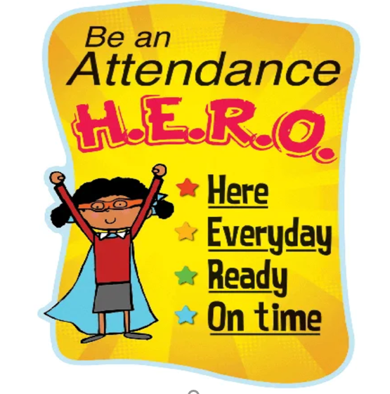
Why is school attendance important?
The Scottish Government (2023) state that high rates of attendance in schools is a key priority of our education system and all local authorities have included attendance as a core stretch aim as part of wider health and wellbeing for the next three years.
Regular attendance at school is vital in helping children to develop strong foundations for long-term mental and physical wellbeing. In addition, there is a direct correlation between school attendance and achievement in education. It is reported that children who attend school regularly achieve greater success not only academically, but also socially and in relation to longer term employment prospects (Kearney, Heyne and Gonzalvez, 2023).

House Point Challenge

Every month we have a house point challenge where children can earn tokens for their house by working together to show our school values and our focus this month is Friendship February – Appreciation. During our assemblies we have been looking at the different ways that we can show appreciation. We have also learned the Makaton sign for appreciation – see if your child can show you this at home!

Local Opportunities….
Please see the information below for some events coming up in our local area.
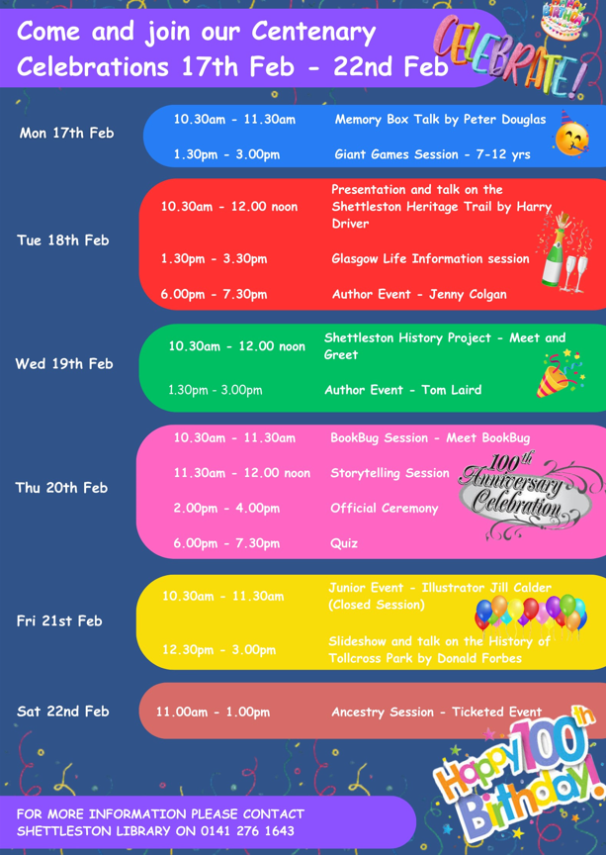



Family Engagement – Parents as Partners!
We are looking forward to welcoming parents, carers and relatives to our family engagement sessions. Class teachers have been working hard to plan activities which will allow your children to share their learning with you. Some classes are going to showcase literacy and phonics using our new magnetic boards, some are going to show off their maths skills and maybe test their parents too. Your child’s teacher will send out more information, including dates and times.

Last week was the launch of our ‘Eastbank Family Fun’ supported by our partners at Fuse. This 6 week programme for Primary 2 and Primary 3 pupils gives parents and carers the opportunity to play alongside their child using games. This first week was a huge success with lots of learning and fun taking place! Looking forward to the next sessions.
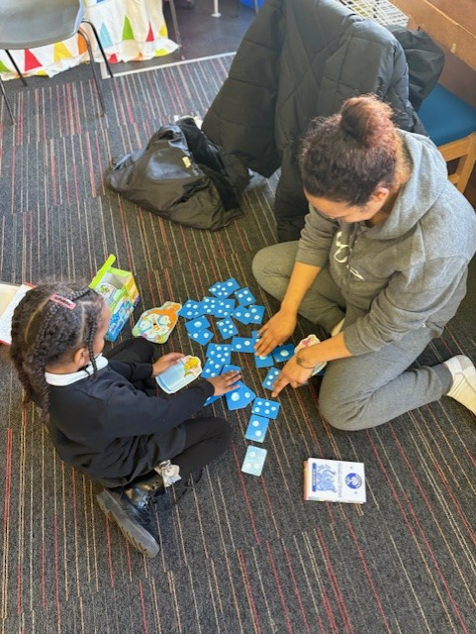
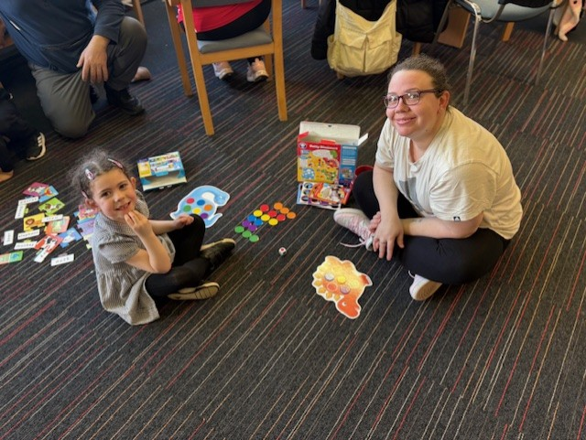


Mrs Laing aims to roll out more family engagement and learning opportunities across the school. Keep your eyes peeled for a parental survey, coming soon!

Keeping Us Safe Focus – Online Safety
We have selected Online Safety as the focus for our Mid-Term newsletter to coincide with the purchase of new devices over the Christmas holidays. We are spending an increasingly worrying amount of time supporting children and their families with incidents centred around social media and games consoles.

Many of our children now use a range of social media apps and sites such as Snapchat, TikTok, Instagram and WhatsApp. There are lots of benefits to social networking. Children can stay connected to friends and family and indeed learn many different things from making slime to other languages.

Like most things, there can be negatives too. For children there are risks that you should be aware of, to help keep your child safe on social media and understand that the legal ages for using such sites and apps.

Social Media Age Restrictions.
Is your child old enough to even be on the site? Chances are they aren't, as the minimum age requirement for most sites is 13+, and even this is a guide. Did you know the age restrictions for the below?




13+ TikTok

13+ Instagram
13+ Snapchat
13+ Youtube
13+ Facebook
16+ Whatsapp
It can be difficult to prescribe a precise age limit for social media sites as children need to have the social and emotional skills to cope with the demands of social media. However, it is important to adhere to the legal age requirements as they are in place for your child's protection sites, ensure you are monitoring their use. 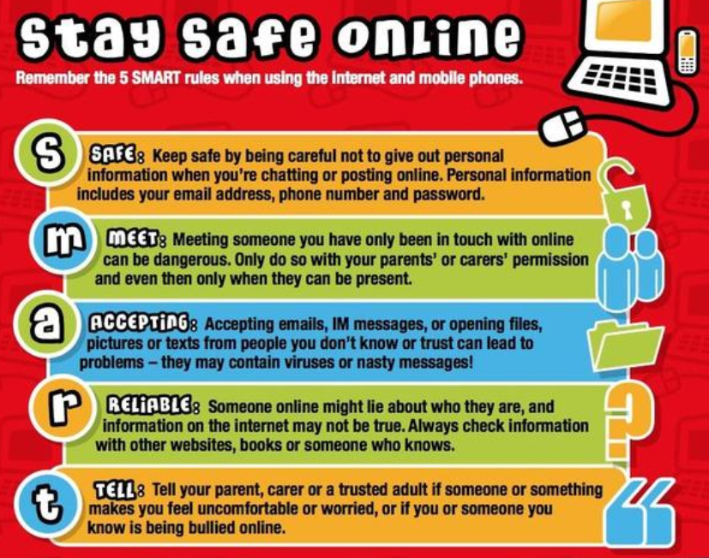

Twitter / X / Bluesky

Eastbank primary school are now on Bluesky. We still have our twitter/X account but we are now using bluesky as it is a much nicer place to be! Give us a follow on @eastbankprimary.bsky.social

Article 29 – Rights Respecting School
As part of our efforts to achieve our Rights Respecting School Award, boys and girls at Eastbank Primary have been taking part in Article 29 Time on Friday afternoons. Article 29 refers to the article of the United Nations Convention of the Rights of the Child (UNCRC) which states that children have the right to an education that develops their personality, talents and abilities. To help children achieve this, the staff at Eastbank (with some help from our Sports Leaders) have been offering “masterclasses” in areas they are knowledgeable about, and the children are able to sign up for the masterclass of their choice (space permitting). This term the choices have included theatre skills, fine line drawing, film literacy and a transition dance team. We are looking forward to seeing what all our talented pupils get up to and what they’ll achieve next!

Dates for your Diary

February

P4 - P5 Thursday 6th Parent Council Disco 6.00pm-7.00pm
P6 – P7 Thursday 6th Parent Council Disco 7.15pm-8.15pm
Primary 4 Friday 14th Class Assembly – Parents invited – 9.30am
Primary 7 Thursday 13th Swimming Session - Gorbals
Whole School Monday 17th – Tue 18th February Mid-term break
Whole school Wednesday 19th In-Service Day (4)
Primary 7 Thursday 20th Swimming Session - Gorbals
Primary 4 Friday 21st Family Numeracy Learning – parents invited.
Primary 7 Thursday 27th Swimming Session - Gorbals

March
Primary 7 Thursday 6th Swimming Session - Gorbals
Primary 2 Tuesday 4th Class Assembly – World Book Day - Parents invited – 9.30am
Whole School Thursday 6th World Book Day – Dress Up Day!
Primary 1 Tue 11th – 1st Apr Multi-Sports After School Club (4 weeks)
Primary 5/4 & P5 Tuesday 11th Trip to Stirling Castle 9.00am-3.00pm
Primary 7 Thursday 13th Swimming Session - Gorbals
Primary 2 Thurs 13th – 3rd Apr Mini Kickers After School Club
Primary 5 Friday 14th Fun Run – Tollcross – 9.30am
Primary 7 Thursday 20th Swimming Session – Gorbals
Whole School Thursday 20th Parent Council Meeting – 6pm
Primary 3A & P3B Friday 21st Class Assembly - Parents invited – 9.30am
Whole School Wednesday 26th Parents Evening 3.30-8.30pm
Primary 7 Thursday 27th Swimming Session - Gorbals
Primary 1 & P2 Monday 31st Baby Strings Concert – 9.45am – Parents invited
Primary 3, P4 &P5 Monday 31st Baby Strings Concert – 11.00am - Parents invited

April
Primary 7 Thursday 3rd Swimming Session - Gorbals
Whole School Friday 4th Eastbank STARS Talent Show 1.15 - 2.15pm
Parents of performers invited
Whole School Friday 4th School closes at 2.30pm for Easter Spring Break
Whole School Monday 7th – Mon 21st School closed Easter Spring Break
Whole School Tuesday 22nd School re-opens – 8.50am

A few reminders….

Whole School Soft Start
All children are encouraged to go straight into class from 8.50am to get ready for the day and of course enjoy some ‘play’ and social time with their friends as well as fun challenges. Any children entering after 9.00am should enter through the School Office Entrance Hall. Children entering school following the 9am bell will be marked as late.

Nut Free Zone
Please do not bring nuts or products containing nut traces into school as all Glasgow City Council Schools are nut free zones. This includes Kinder and Nutella products.

School Lunch System
Parents should use Parent Pay to pay for and preorder their child’s lunch in advance, at home. Thank you to those parents who do preorder as this saves invaluable teaching and learning time at the start of each day. If you are unsure of how to access Parent Pay please call the school office for advice. We would really appreciate it if more lunches, if not all lunches, could be ordered out with the school day. Thanks as always for your support with this.

Parent/Carer Meetings

Life can be very busy, and the school understands this however if you are unable to attend a meeting, please can you let the school know in advance as soon as possible. This just allows for these meeting time slots to be given to other families.

School Values
We have been patiently waiting to launch our updated value characters and have been working with a graphic designer to produce digital versions of our pupil drawn characters. We plan to launch our new characters at our in school house assembly Friday 28th February. In the meantime, we have our stars shown below!

Final Remarks
We have lots of family activities planned over the next two months and look forward to seeing as many parents as possible attend these. We know that parents and carers are busy so if you can’t make any of our events, please feel free to nominate a grandparent, aunt or uncle to attend in your place. We look forward to welcoming you to school and working together to improve our pupil learning! If you have any comments, feedback or suggestions for improvement then please contact us by phone or email headteacher@eastbank-pri.glasgow.sch.uk .

Best wishes,

Gayle Minnis Trish Walker Sinead Armstrong Emma Laing Sarah Campbell
Head Teacher Acting Head Teacher Depute Head Teacher Acting Principal Teacher Acting Principal Teacher

