Eastbank Primary School
Standards & Quality Report Session 2023 – 2024

This summary report is provided for parents/carers and partners to outline our achievements and improvements during session 2023 - 2024 and to share our improvement priorities for 2024 - 2025. Throughout last session we took forward our improvement priorities as detailed in our school improvement plan. Using our approaches to self-evaluation, we have detailed in this report the impact of our work and identified how we plan to continue to improve outcomes for our children and young people.

Our achievements and improvements 2023 – 2024
Our School Context
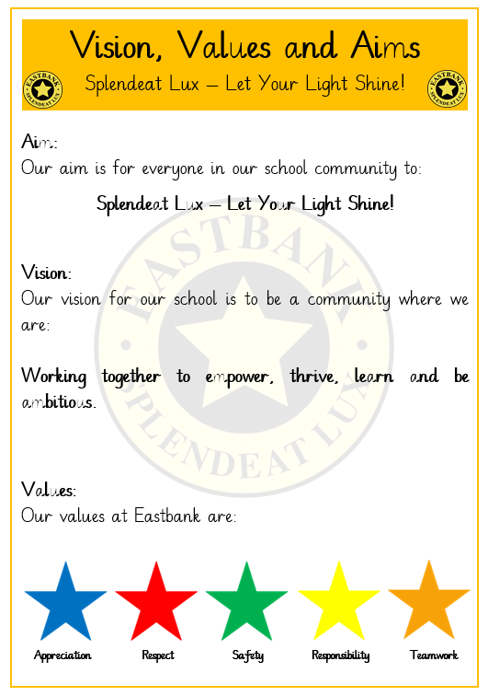
Eastbank Primary is a happy and welcoming school with an inclusive school community who come together as a ‘school family’ to meet the needs of all children in a safe and supportive learning environment. Our school motto ‘Together Eastbank Achieves More’ reflects the positive culture of our school and focus on collaborative learning, achievement and high expectations for all children and families. Our values-based House System, communal displays, shared language, characters and celebrations at weekly assemblies ensure school values are high profile and discussed daily.

Improving our School
Our School Improvement Planning incorporates Scottish Attainment Challenge priorities and opportunities afforded via the additional Pupil Equity Funding (PEF), working towards closing the poverty related attainment gap in our children’s progress. This session:

Leadership of Change
*We worked together to refresh our long-standing school vision, values and aims.
*We established a Rights Respecting Schools Committee and enrolled in the Rights Respecting School recognition programme.
*All teaching staff participated in a Professional Inquiry by identifying an aspect of teaching and learning they wished to improve. The process increased opportunities for self-reflection, moderation and professional dialogue amongst all staff and led to greater ownership of class and school attainment data.
*We continued to look inwards with staff working together in Teacher Trios, visiting each other’s classrooms and sharing reflections and offering feedback to each other and outwards, working with colleagues across the learning community to create The Eastbank Learning Community Mission to Transition improving both our nursery and secondary partnerships and sharing of information.

Developments in Learning and Teaching and Assessment
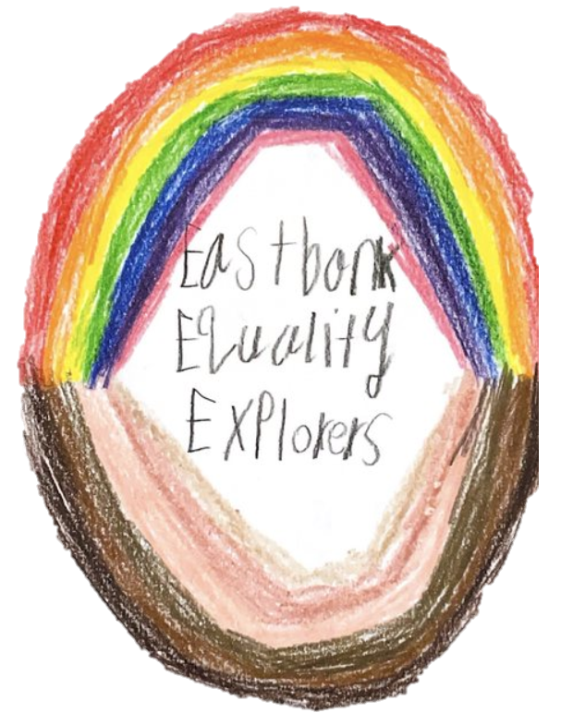
* Our Eastbank Explorers Pupil Group created a ‘This is Me’ learning resource celebrating inclusion and diversity within our school community including the introduction of new novel studies at each stage to explore diversity and challenge racism, religious intolerance and equality. This group also led our Bullyproofing our School Week and updated our school Anti-Bullying Logo and displays around the school.
*We continued to host and expand our annual Future Me £1 Class Challenge and our Future Me Developing the Young Workforce Fortnight, welcoming 37 visitors from over 29 services and industries including a number of parents and local businesses.
* Our PEF funded CREATE4EAST Music Programme continued to provide a wide range of shared musical experiences across the school. Our P1-P4 Baby Strings, P5-7 Sensational Strings, Brass Group and Choir continued and we benefitted from Fiddle workshops for our P7 pupils delivered by the Celtic Connections Team and additional singing sessions for our P1 children. Musical experiences continue to support phonological awareness, concentration, listening and co-operation skills.

*Our infant team worked together to continue to enhance approaches to Playful Pedagogy at Eastbank. All infant classes access the Star Hotel twice weekly accessing play and learning associated with Expressive Arts, Science and Technologies. Food for Thought funding allowed new resources to be bought to enhance experiences associated with food technology too. The Outdoor Kingdom was reviewed to ensure infant learners experienced intentional and responsive learning outdoors. The learning is now captured in Big Books and sits alongside our curriculum planners to ensure that the learning reflects learning taking place in class.
*P7 teachers piloted the use of the GCC Monitoring and Tracking Tool which improved the pace and focus of tracking conversations and reporting. This was extended to all staff in term 4 and will be piloted across the school in session 24/25.

Progress in Promoting Well-Being, Equality and Inclusion
* Our refreshed values were voted on in consultation with stakeholders and have been chosen to incorporate the UNCRC Rights of the Child.
*We worked alongside a coach from Barnardos to ensure consistent delivery of our Promoting Positive Thinking Strategies (PAThS) programme. Class displays, pace of lessons, a shared language, parent information sessions, weekly inputs at assemblies and training for our Support for Learner Worker Team has raised the profile and effectiveness of the programme across the whole school.
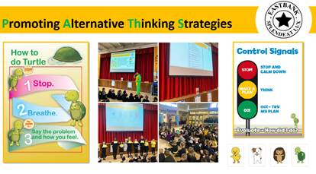

*PEF funded Withkids Play Therapists continued to work with target children, their families and teaching
staff. The therapeutic sessions promote feelings of connectedness and trust, reduce stress and facilitate resilience.
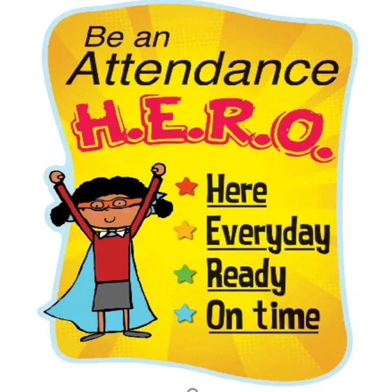
*We aimed to improve school attendance across the school by re-visiting our absence management practices and procedures. We shared our action plan with all stakeholders and implemented a robust system of monitoring and family liaison. Individual children and families made considerable gains but our overall school attendance decreased further to 89%. We will continue to work together to improve this and encourage all children to be:
*Our Boys and Girls Football Teams and Netball Team continued to attend a range of sporting events and competitions, looking super in their new playing kits, thanks to our friends at Fuse.
*We continue to value parents as partners hosting a range of family learning opportunities including a Muffins and Maths programme, Stay and Play Club, Family Cook School, Triple P Classes, First Aid Courses through Clyde College and a range of events hosted by our Parent Council including a Whole School Fun Day.
Progress in Children’s Learning/Raising Attainment and Recognising Achievement
* Raising attainment in literacy and numeracy is an annual feature on the school’s improvement agenda. This session a refreshed whole approach to the teaching of spelling has supported teachers to ensure high quality spelling lessons are planned and delivered.
* We continue to host regular SLT and Class Teacher monitoring and tracking conversations using a range of assessment data to develop more challenging and stimulating learning opportunities and ensure shared standards and expectations across the school.
A wealth of school data provides a coherent narrative of progress over time and has led to the identification of trends and key areas for improvement. As a result, a range of individualised, targeted support groups of children and families benefit from additional supports and interventions.
*Most children in the upper stages of the school confidently adopted a range of buddying and mentor roles and responsibilities such as Reading Buddies, Super Sevens and Learning Buddies at a local nursery. As well as participation in a range of pupil leadership roles including our STEM Team who hosted a STEM competition for the whole of the Eastbank Learning Community.

 | How Good Is Our School 4 Quality Indicator (QI) | Evaluation
 | Leadership of Change (QI 1.3) | Very Good
 | Learning Teaching and Assessment (QI 2.3) | Good
 | Ensuring Wellbeing Equality and Inclusion (QI 3.1) | Very Good
 | Raising Attainment and Achievement (QI 3.2) | Good

Our improvement plan priorities 2024 – 2025
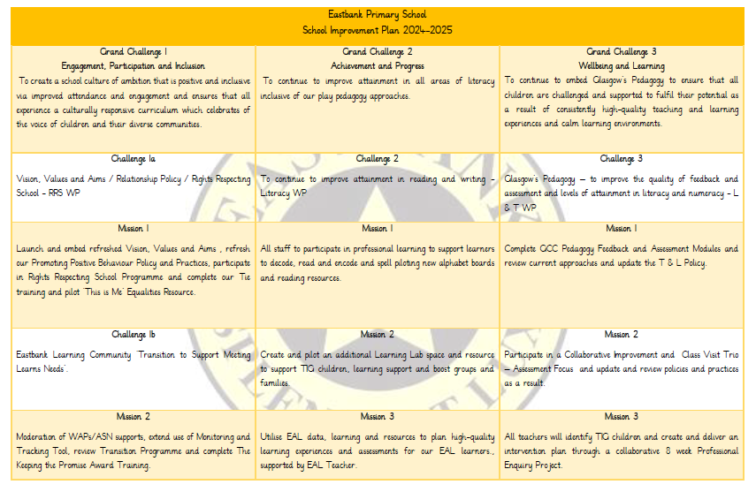

How to find out more about our school
Contact us directly if you require further information about our school or if you wish to comment on this report.

Our contact e-mail address is: headteacher@eastbank-pri.glasgow.sch.uk

Our telephone number is: 0141 778 6659


Our school address is: 80 Gartocher Road, GLASGOW, G32 OHA

Further information is also available in our newsletters, on our school website, and in our school handbook.

