
Winter Newsletter 2024
Splendeat Lux – Let Your Light Shine!
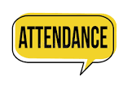
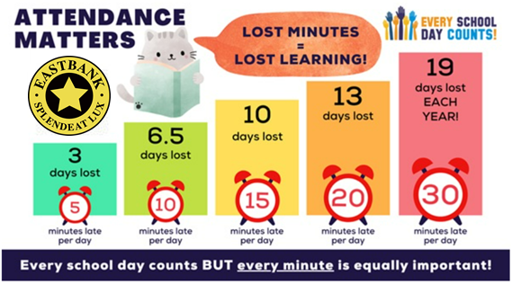
Attendance
Full attendance and punctuality are key factors in helping our young people to be successful. These are skills that last a lifetime. Improving Attendance is a key area of focus for all Glasgow schools and I am pleased to share that our overall attendance has improved! Thank you so much for your continued support with this. In line with Glasgow City Council Policy we will continue to write to those families whose attendance goes under 90%. This includes those who were absent due to illness. We appreciate that children are sometimes not well and would expect them to be off for this, however this is still recorded as a school absence. We review attendance every 6 weeks to either inform you that it is below 90% or ask that you meet with us to discuss ways forward to maximum attendance and progress for all learners. Thank you for your support and understanding with this process.

Attendance Overview since August.
P1a 96% P5 93%
P2/1 93% P5/4 89%
P2 94% P6 93%
P3A 91% P7/6 90%
P3B 91% P7 91%
P4 94%

Appreciation
Respect
Responsibility
Safety
Teamwork


Staffing Updates
We are delighted to introduce our lovely new Acting Principal Teacher, Mrs Emma Laing. Mrs Laing joins us to cover Miss MacLaughlin’s Principal Teacher Post and is looking forward to getting to know you all over the Christmas period. Mrs Laing will be supporting the boys and girls on our Top Floor and working alongside pupils, staff and parents to support learning in both literacy and numeracy.

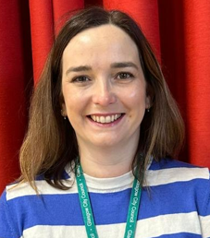
We have sad staffing news too - our wonderful Mr Kiernan will be leaving us on Friday, 13th December. Mr Kiernan is leaving us to begin an exciting new role as Head Teacher in a Family Centre in East Renfrewshire. We wish Mr. Kiernan all the best in his new post – we know that he will do a wonderful job but we will miss him at Eastbank!

As a result of Mr Kiernan leaving, Mrs. Campbell will undertake the role of Acting Principal Teacher. Mrs Campbell is an experienced member of our Eastbank Team and brings a wealth of knowledge and skills to the role. We know that she will help our pupils let their lights shine!

Our lovely Mrs Nicholson has left to start her maternity leave and we welcome Miss Naeem to Primary 3b. We also welcome Mrs Nolwenn Alexandre and Ms Lucy Hough who are working in P7/6 and P6 to support with staff absence.

MacMillan Coffee Morning and Bake Sale
We would like to take this opportunity to thank you all for your tremendous support during our Macmillan Coffee Morning and Bake Sale. We raised over £300 for MacMillan Cancer Research and enjoyed some community time together during the P1 and P2 Coffee Morning. The success of such events only comes from your wonderful support and we are so very grateful. Every child in the school enjoyed a sweet treat on the day too! Thank you! Together Eastbank Achieves More!


Healthy Personalities
We are continuing to encourage Eastbank healthy personalities in November and December! We are trying to promote healthy snacks for break time and have been presenting stickers for children who bring fruit for their break time snack. Prizes are also shared at assembly for the healthiest personalities in each class. Keep up the good work!
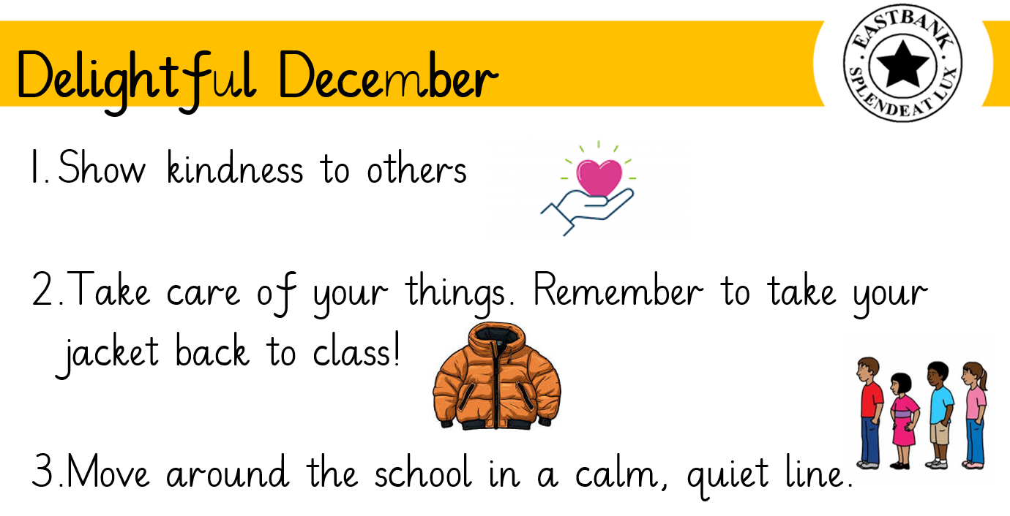

House Point Challenge
Every month we have a house point challenge where children can earn tokens for their house by working together to:


Keeping Us Safe – December – Winter Weather
Our ‘Keeping Safe’ topic this month is being safe in Winter Weather! Last week saw a cold spell with an icy playground and even a little bit of snow. Out MUGA pitch was so icy that we used other areas of our playground at break time and let children back on the pitch when the ice had thawed at lunch. People are twice as likely to break a bone in winter and some hospitals see a 500% increase in A&E visits during icy weather. We always try to get outside at break and lunch if the playground is not too wet and it is safe to do so. Please send children in wearing appropriate clothing and put names on everything! We have a large collection of lost property so if you are missing something from home, please come in and have a look. We also have spare jackets and clothes on our rail which parents/carers are welcome to take if needed.

December Diary Dates – additions or changes to original calendar in bold.
Primary 1- 4 Wednesday 4th Fluoride Varnishing Day – 9am
Primary 4 Thursday 5th Class trip to Sandyhills Church – 9-11am
Primary 2 & 3 Monday 9th Baby Strings Concert – 9.45am – Parents invited
Primary 4 & 5 Monday 9th Baby Strings Concert – 11.00am - Parents invited
Whole School Wednesday 11th Christmas Lunch for children – book online
Primary 6 Thursday 12th Class trip to Sandyhills Church – Christmas visit – 9:30-11:30am
Whole School Thursday 12th Christmas Fayre 6.00-8.00pm

Whole School Friday 13th Santa Dash – School Muga – Christmas Jumper/Santa Hats/Tinsel

Primary 1-3 Tuesday 17th P1-P3 Christmas Nativity 9.45am or 1.30pm
Primary 4 & 5 Tuesday 17th Dunedin Consort 3.pm – 5.30pm

Primary 1-3 Wednesday 18th Christmas Party - Plus Special Guest –
P1, P2, & P3. Parents welcome to join us at the time specified.
Primary 4-7 Wednesday 18th Christmas Parties 1pm-3pm
Whole School Thursday 19th Parent Council Panto – 9.30am
Whole School Friday 20th Non-Uniform Day!
Whole school Friday 20th School closes 2.30pm for Christmas Holiday

School will close for the Christmas Holidays at 2.30pm on Friday 20th December and re-open on Monday 6th January 2025 at 8.50am.

Sensational Strings Showcase - Monday, 9th December
All primary 2 and 3 parents are invited to join us at 9.45am and primary 4 and 5 parents at 11.00am. This will be a short showcase to give you a little insight into Music Mondays at Eastbank.

Christmas Jumper Day - Friday 13th December 2024
Our Santa Dash is a Fun Run which will take place, for all P1 – P7 pupils, on Friday 13th December on our Muga Pitch. Budhill Park is still under construction unfortunately! Pupils can wear festive hats and Christmas jumpers if they wish. Please support by sending in any loose change that you can spare and we will use all funds raised to invest in some new playground equipment and games for the Spring/Summer season at Eastbank. Please ensure that your child is wearing appropriate footwear and a jacket for the weather on the day.

Angel Express – 2024 Christmas Nativity – Tuesday, 17th December
Pupils from P1-P3 are busy rehearsing for a fabulous performance of ‘Angel Express’ on Tuesday 17th December at 9.45am and 1:30pm. Tickets cost £2.50 and can be ordered using the tickets request letter. Children should give this to their class teacher. A separate letter has been issued to P1-P3 regarding costumes. Please join us for what I am sure will be a lovely heart-warming experience!

P1 – P3 Christmas Parties - Wednesday 18th December
Our P1-P3 parties will be held on the morning of Wednesday, 18th December. Children may choose to wear party clothes on this day. Please see times below for the parties:

Primary 1 | 10:00am-10:30am
Primary 2/1 | 10:00am-10:30am
Primary 2 | 10:45am-11:30am
Primary 3a | 10:45am-11:30am
Primary 3b | 10:45am-11:30am

You are invited to your child’s party at the above noted times to see our special guest.

P4-P7 Class Party Afternoon -Wednesday 18th December
Classes will enjoy a morning of Christmas crafts and fun followed by class and stage parties in the afternoon. Children are able to wear non-uniform / party clothes all day or change at lunchtime.

Seasons Greetings
As always we have a fun filled festive season in store and I would like to thank you for your anticipated support and encouragement. On behalf of all staff and ourselves may we wish you a very Merry Christmas and a wonderful Happy New Year!



Gayle Minnis Trish Walker Sinead Armstrong Brian Kiernan Emma Laing
Head Teacher Acting Head Teacher Depute Head Teacher Principal Teacher Acting Principal Teacher

